

**Tezpur University**

Minor Project Progress Report on -

“Malware Detection Using a Chatbot”

Abhilash Chutia [CSM23010]

Bishal Sharma [CSM23024]

Submitted to-

Dr. Dhruba Kr Bhattacharya

Sr Professor, Department of CSE

**Project Overview**

The goal of this project is to achieve an intelligent working Chatbot with the capabilities to consult an user through a series of questions at the end of which the Bot will be able to correctly identify if the user machine is infected by a malware and the type of malware.

By leveraging Natural Language processing, the bot is able to assist as a cybersecurity helper in identifying suspicious behaviour or indicator of compromise depending on the user inputs.

This project is a combination of chatbots, machine learning and cybersecurity.

**Progress Summary**

**Understanding and Presenting Chatbot Basics:** Analysing chatbot technology, its applications, and potential in cybersecurity.

**Addressing Chatbot Bias:**

Exploring how biases can affect chatbot interactions and ensuring an unbiased user experience.

**Developing Knowledge-Based and Detection Chatbots:**

Implementing a General knowledge bot using the Gemini API to answer questions about India.

**Malware Analysis and Presentation:**

Researching and presenting key concepts of malware to inform the chatbot’s detection capabilities.

**Developing Malware Detection Chatbots:**

Using the knowledge from the previous trial with the Gemini API, develop another Bot that can handle user interaction and identify malware threats.

**Detailed Summary**

**1. Presentation on Chatbot**

This presentation covered the following topics:

1. What is a chatbot?

2. Types

Rule Based Chatbot

Open Ended Chatbots

3. Hardware/ Software Requirements

4. Python Libraries

Natural Language Toolkit [ntlk]

Transformers [Transformer Models]

Scikit-learn [Machine Learning Algorithms]

TensorFlow [Deep Learning Models]

Django [Web Interface]

5. Advantages

6. Use Cases

7. Challenges faced by Chatbots

**2. Basic Chatbot**

A basic chat bot has the following requirements to function:

1. A intents data file containing the interaction expected of the bot. This is in the form of a json file

2. Word Lemmatizer is used to reduce words to their base forms

3. Punctions are ignored

4. Words are extracted from the patterns and stored in a list called “Words”. Unique intent tags are stored in a list called “Classes”

5. The pickle library is used to save the vocabulary and classes for future use.

**Model Training**

1. TensorFlow’s Keras library is used to create a sequential model.

2. This model has two hidden layes with 128 and 64 neurons respectively. These layers extract features from the given data and learn about the complex relationships between the words and intents.

3. Dropout layers prevent overfitting of the training data.

4. The Stochastic Gradient Descent [SGD] is used to train the model.

5. The model is saved as “chatbot_model.h5” to be used again.

**Libraries Used**

1. Random

2. Json

3. Pickle

4. Numpy

5. TensorFlow

6. Ntlk

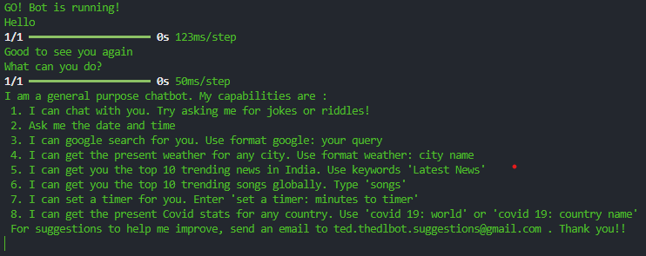

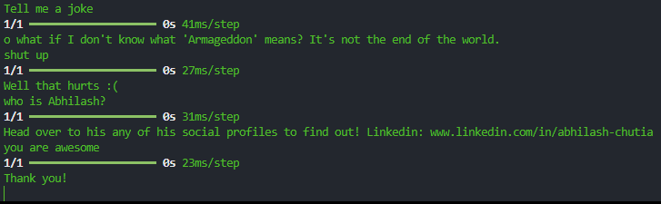

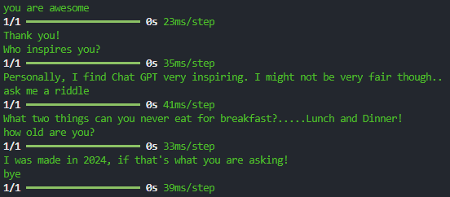

**3. Presentation on Bias**

This presentation included the following topics

1. What are Biases?

2. Types of Biases

Data Bias

Data Collection

Data Representation

Historical Bias

Selection Bias

User Interaction Bias

Algorithmic Bias

Presentation and Ranking Biases

Gender Bias

3. Impact of Biases on Chatbot

4. Strategies for mitigating Biases in Chatbots.

**4. Indian General Knowledge Bot**

The libraries used here are:

1. Flask

2. OS

3. Google Generative AI

The chatbot is designed as a web application.  
The users can interact with the bot by typing into a text field.

The Flask framework is used to handle user input and communication with the GenAI model.

**GenAI Integration:**

1. API key is configured to access the large language model capabilities.

2. Gemini 1.5 flash model is used for response generation, fluency and factual accuracy.

3. A chat session is initialized to provide a history of previous questions with the bot.

**Flask Application:**

A Flask application is created to handle web requests and responses.

**Routing:**

The root path is mapped to the index function which renders the interface Html template for the chatbot.

The ask path is mapped to the ask function which handles user interactions.

**Overview:**

The chatbot allows user to ask questions related to India. The Gemini Ai model utilizes it knowledge and understanding to generate the most informative response.

If the user asks questions unrelated to the topic of India, the model kindly lets the user know of its limitations and redirect the user to questions related to India.

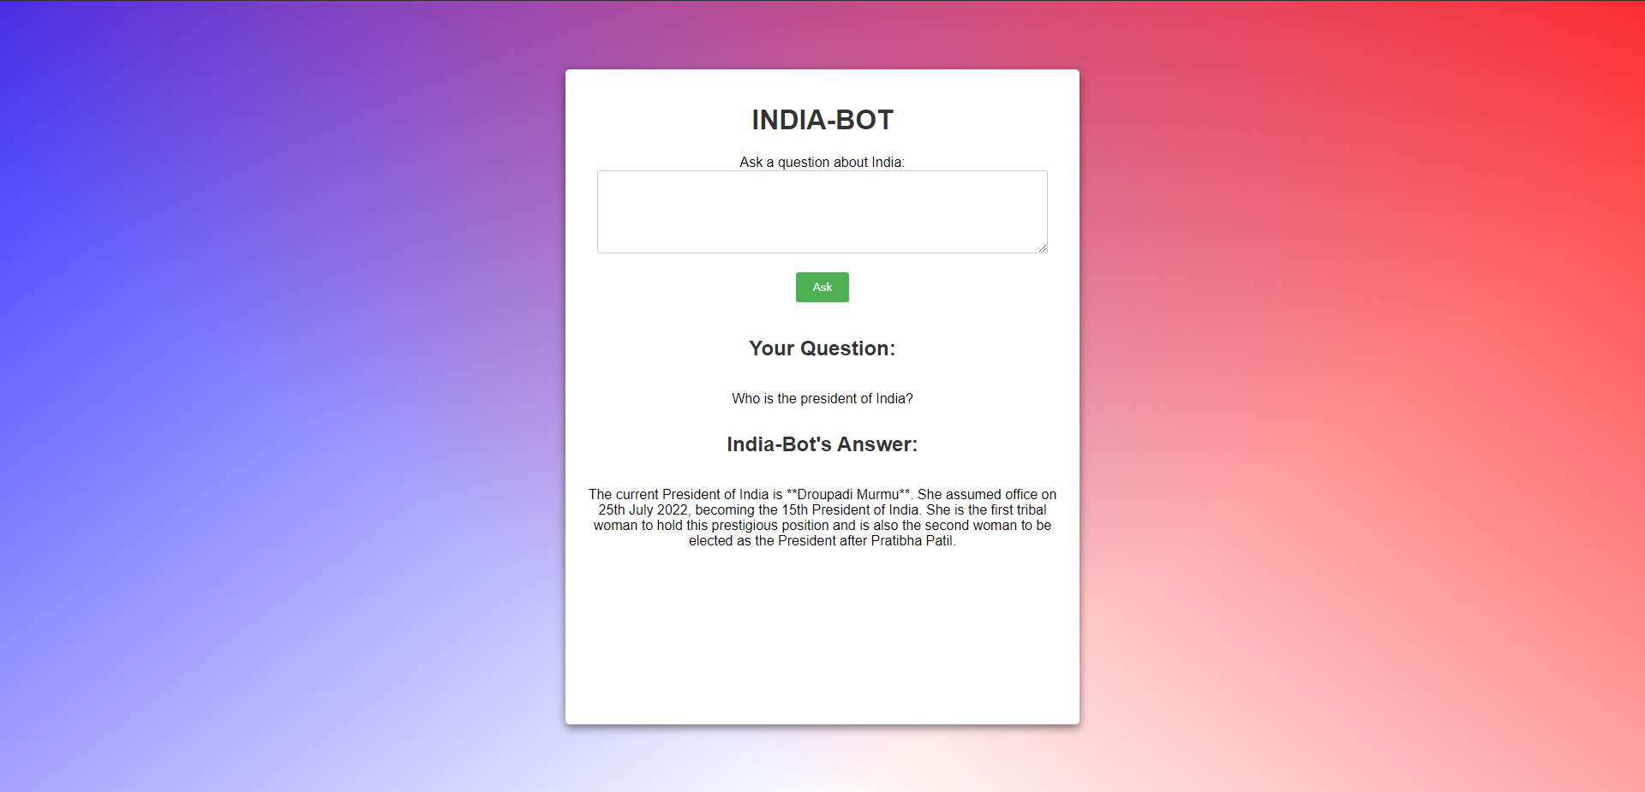

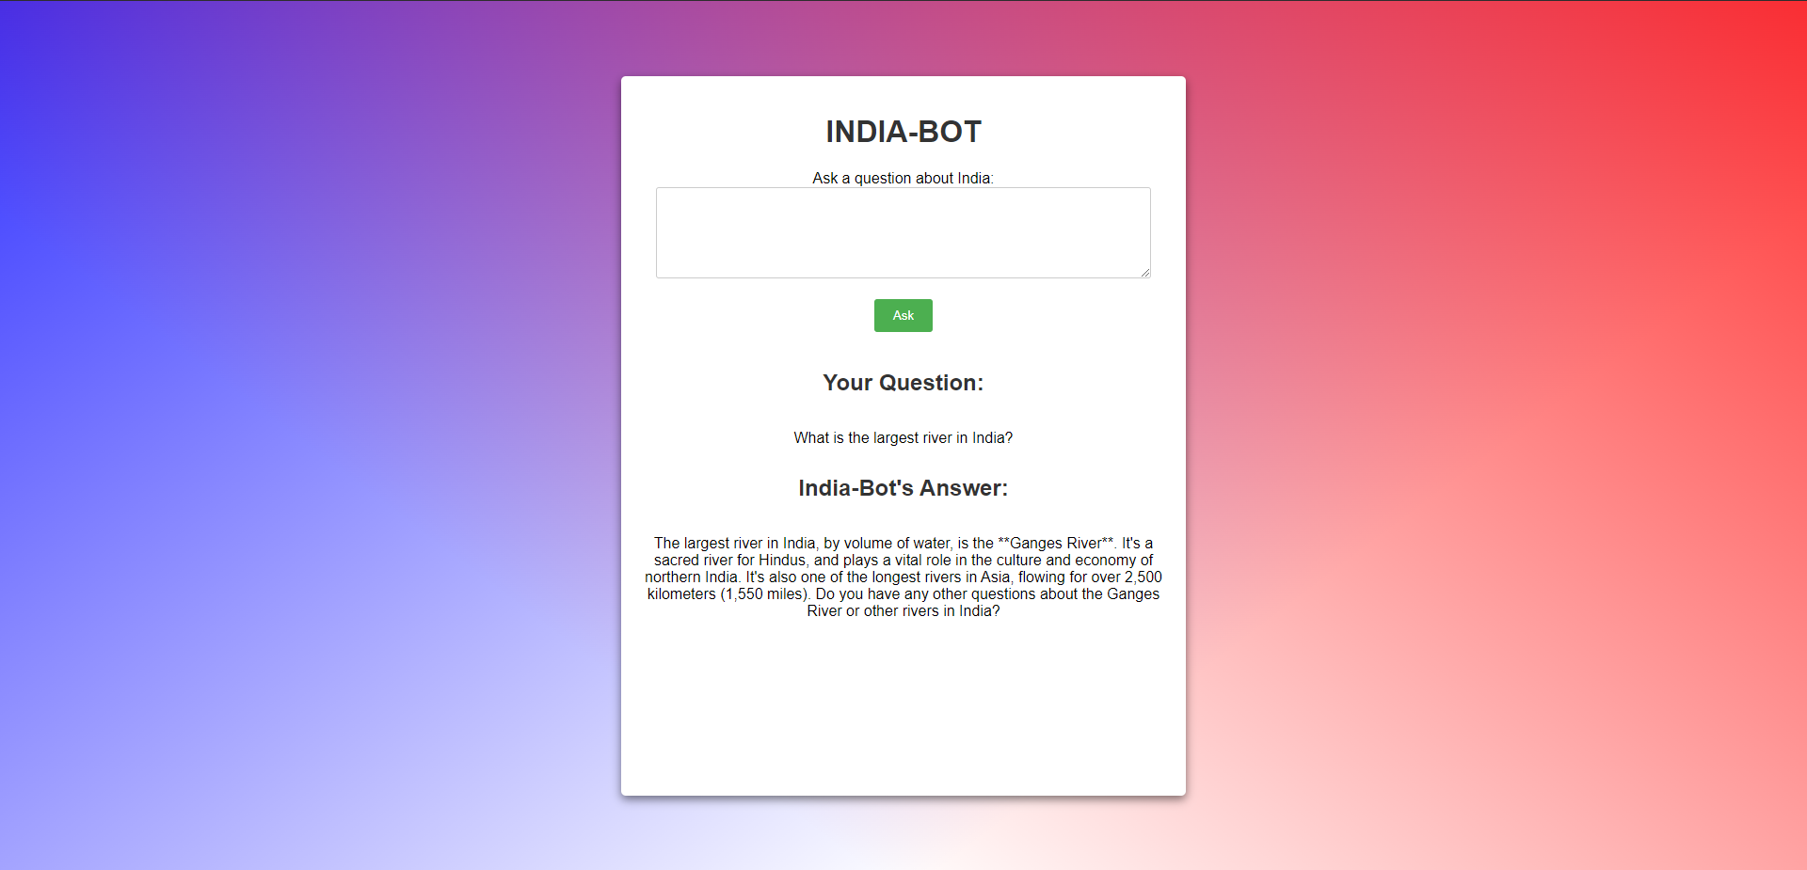

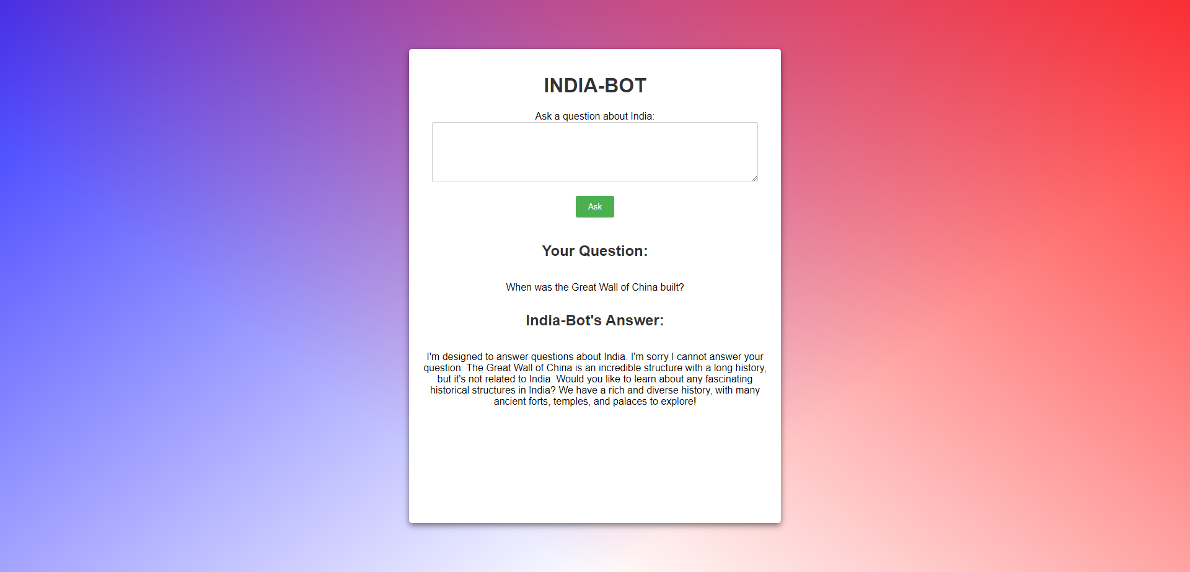

**5. Presentation on Malware**

The Presentation on Malware consisted of the following topics:

1. What is Malware?

2. Types of Malware

Viruses

Ransomware

Worms

Trojans

Spyware

Botnets

3. Signs of Malware infection

4. Steps to take on Malware Detection

**6. Sherlock – Malware Detective**

The libraries used here are:

1. Flash

2. OS

3. Google generative AI

The chatbot is designed as a web application.  
The users can interact with the bot by typing into a text field.

The user input is stored as history so that the the AI model can remember the context and generate appropriate responses.

The Flask framework is used to handle user input and communication with the GenAI model.

An API key is configured to access the large language model capabilities.

Gemini 1.5 flash model is used for response generation, fluency and factual accuracy.

A chat session is initialized to provide a history of previous questions with the bot.

**Overview**

**Introduction:**

The chatbot introduces itself as "Sherlock" and starts by asking questions about the user’s operating system and system setup.

**Interactive Q&A:**

Sherlock poses a series of questions to understand user symptoms, system characteristics, and any recent abnormal behaviour.

**Symptom Analysis:**

Based on user responses, Sherlock provides insights on whether the system might be infected.

**Session Continuity:**

Sherlock retains the chat history for a seamless conversational experience, allowing it to remember previous responses and build on them.

The "Malware Detection Using Chatbot" project provides an innovative, user-friendly way to assist individuals in identifying potential malware issues on their systems. This project demonstrates the potential of AI-driven tools to assist in cybersecurity awareness and initial malware assessment.

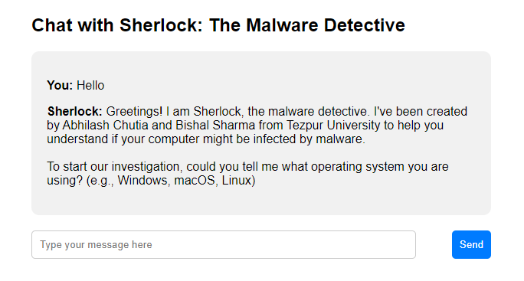

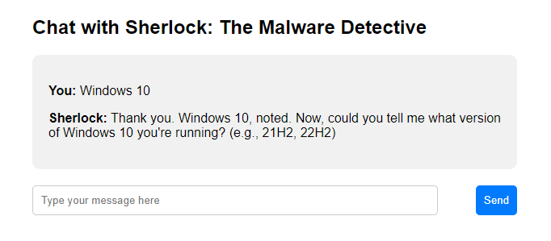

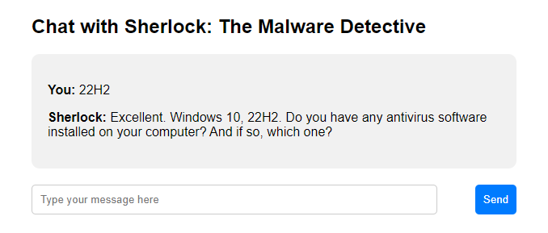

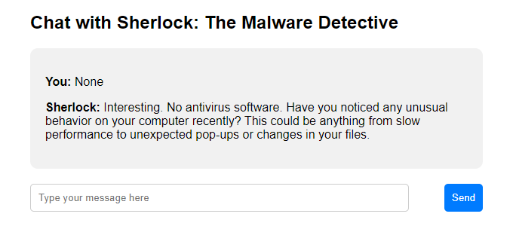

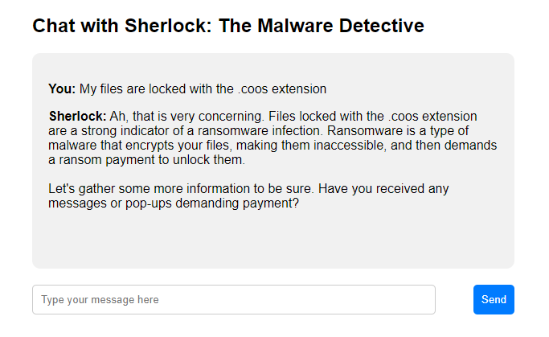

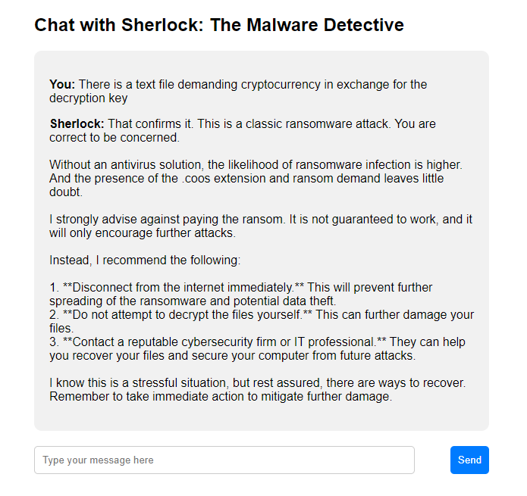

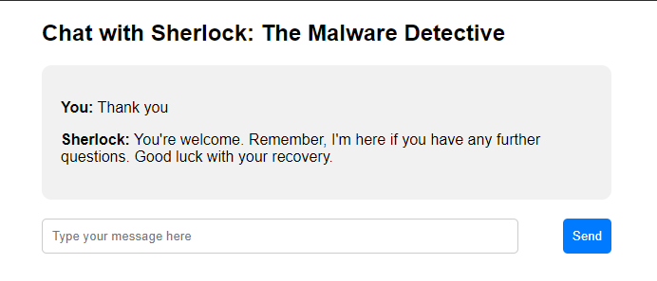

**Summary**

The "Malware Detection Using a Chatbot" project, undertaken by use, Abhilash Chutia and Bishal Sharma under Dr. Dhruba Kr Bhattacharya, aims to develop a chatbot that identifies malware on a user’s system. This chatbot uses natural language processing to interact with users, helping detect suspicious behaviour that could indicate malware. Key stages of the project include:

**Chatbot Basics and Bias:** We studied chatbot functionalities, types, and applications in cybersecurity, addressing potential biases that could impact user interactions.

**Chatbot Development:** Initial versions included a general knowledge chatbot using the Gemini API to answer questions about India. This served as a foundation for building a more advanced malware-detecting bot.

**Presentations on Malware:** Presentations on different malware types (viruses, ransomware, etc.) and indicators of infection helped enhance the chatbot's diagnostic capabilities.

**Sherlock – The Malware Detective:** Named "Sherlock," this chatbot functions as an interactive web application using Flask and the Gemini AI model. "Sherlock" asks users about system details and symptoms, analysing responses to determine potential malware presence. It remembers chat history for coherent, context-aware responses.

This project exemplifies how AI-powered tools can aid in cybersecurity by identifying malware threats, creating an accessible and user-friendly method for initial malware detection.